Seminar Programme

Day 1: Tuesday 1st March 2011

Venue: Platinum Suite

11,15 -12,15 The Role of Architects in a Resource Stressed World

In a resource stressed world, it is important for architects to be wise custodians, obediently sustainable while also being adventurous. How can architects retain excitement, dignity and quality while designing buildings in which wisdom about the best use of resources is a constant?
Sunand Prasad, Co-founder and senior partner, Penoyre & Prasad LLP, former President RIBA
Mrs. Ellen van Loon, Partner, OMA
Jim Heverin, Associate Director, Zaha Hadid Architects
Professor Chris Wise, Director and co-founder of Expedition Engineering and Think Up
Architect Mario Cucinella: Founder Mario Cucinella Architects, visiting Professor at Nottingham University, former architect at Renzo Piano Building Workshop in Genoa and Paris

Venue: South Gallery, Premier Suite 2

10,00 – 12,30 Towards Nearly Zero Energy Buildings: The Innovative System of Governance in Lombardy



The Workshop aims to transfer the innovative experience promoted by Cestec Spa on behalf of Lombardy Region in order to improve energy performances of existing building stock and new buildings. Lombardy implemented EPBD Directive in summer 2007 and set up a governance system (CENED) able to provide a wide knowledge of energy efficiency of buildings in the regional territory (more than 400.000 energy performance certificates of building at the end of 2010). CENED favors a permanent perspective of innovation in the value chain of industry sectors related to buildings.

Venue: South Gallery, S260

12,30 – 13,30 Italian Pavilion Opening Ceremony

Venue: South Gallery, Premier Suite 2

13,30- 14,30 Press Conference

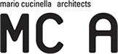

Architect Mario Cucinella: Founder Mario Cucinella Architects, visiting Professor at Nottingham University, former architect at Renzo Piano Building Workshop in Genoa and Paris

14,30- 15,30 Veneto Region
Dottoressa Maria Luisa Coppola, Town Concillor for the economic development of Veneto Region

15,30 – 17,00 The label ClimateHouse – a story of success



Agenzia CasaClima is a public organization which works for the energetic certification of the buildings. In addition the agency offers education programs for the companies involved in the construction industry and promotes ideas for the sensitization of the citizenship about the eco friendly energy solution and climate change. During the conference will be discussed the ClimateHouse Project which promotes energy-efficient and sustainable buildings in South Tyrol, Italy. The conference will discuss: The historical success of the project, The certification, The types of ClimateHouse, The ClimateHotel Project, The long term vision.
PhD. Ing. Ruben Erlacher, Agenzia Casa Clima

Day 3: Thursday 3rd March 2011

Venue: South Gallery, Room 8

10,30 – 11, 30 Ceramic Tiles of Italy: The Green Way


The seminar will firstly discuss the Italian market (the world recognised leader in the ceramic tile production) its history, development and potential achievements.
The second part of the conference will discuss the development in design and aesthetics and the commitment to the environment. The focus will be on the new eco friendly tools and regulations implemented in the sector during the past 25 years. Respecting the environment is today an absolute priority and the first commitment of Italian ceramic tile industry.
The third part will discuss the decrease, in comparison with the rest of Europe, of professional diseases in the ceramic sector.

Graziano Sezzi Confindustria Ceramica
Armando Cafiero Chief Executive Officer Confindustria Ceramica

11,45 – 13,15 The development of the Eco-Sustainable construction in Puglia: energetic efficience and reduction of environmental impact

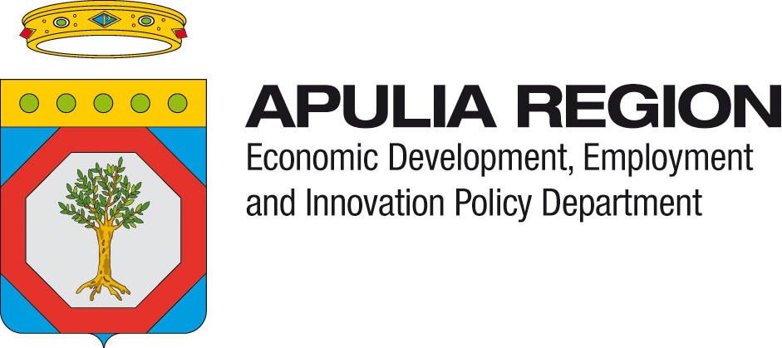

The Apulian District of Sustainable Building
Salvatore Matarrese President DES

Development of Sustainable Building in Italy: Apulia Region Experience
Giuseppe Piccoli: Technical Committee of the ITACA, Italian Federal Regions Association)

Innovative Projects for the Development of Eco-Sustainable Products: From the Urban Solid Waste to the Construction
Orazio Manni CETMA –Planning, Design and Materials’ Technologies Centre

The Industrial Participation in the Energy Efficient Building Public Private Partnership (EeB PPP) at the 7th Framework Program of the European Commission
Stefano Carosio D’Appolonia S.p.A.

The Apulian Distict of Stone
Marco Ielli President Lapideo Pugliese District

Housing in Class A : Updating of housing typology and building in bearing stone in South Italy
Claudio D’amato Guerrieri Professor Politecnico di Bari

14,00 -15,00 SBID – Society of British Interior Design



Vanessa Brady President of Society of British Interior Design

